Vision Cloud SDK

**Building & Running**

* Open solution *VisionCloud.SDK.sln*
* Build

From command line:

* Open a command line (ensure build sln first)
* Navigate to {solution dir} (ie. directory containing VisionCloud.SDK.sln)
* Execute the following:

VisionCloud.SDK\bin\Debug\VisionCloud.SDK.exe

From Visual Studio (debugging):

* Launch in debug: F5 (ensure startup project is VisionCloud.SDK)

**Logging on**

Prerequisites

1. User credentials must first have been created on the Vision Device Management Portal. Check with your Vision Device Management Account administrator to setup the user credentials.
2. Registered Morpheus device in your account
3. A sample app installed on the Morpheus device. You can use the Alien 2 Plunger Controller connector app or the Pressure Sensor app from the App Store or use build an app from source (examples from <https://github.com/ETCorp/morpheus-examples> i.e. Pressure_Sensor or plc_app)

When this is ready, once you have launched the SDK app, enter your username (minimum 8 characters) and password and device name (minimum 4 characters). If successful, you should see a device summary similar to the following:

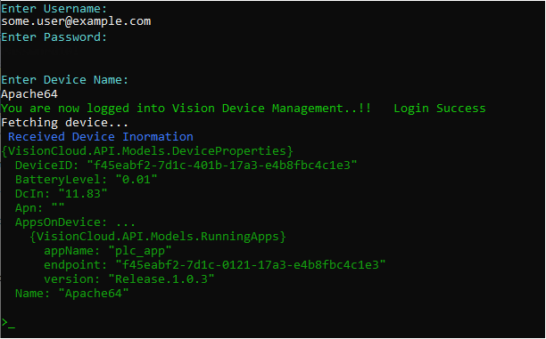

**Commands**

The SDK accepts the following commands (short form / long form):

ls / list  
di / deviceinfo  
sa / selectapp  
cd / changedevice  
rp / replay  
op / operation  
exit / exit

Of these, *operation* accepts six sub-commands:

read / 1  
write / 2  
execute / 3  
observe / 4  
stop-observe / 5  
writeAttribute / 6

**ls | list**  
Usage: ls  
Lists the apps running on the selected device.

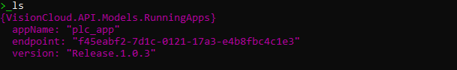

**di | deviceinfo**Usage: di DEVICE_NAME  
Returns device info summary, including ID, battery level, apps running, etc.

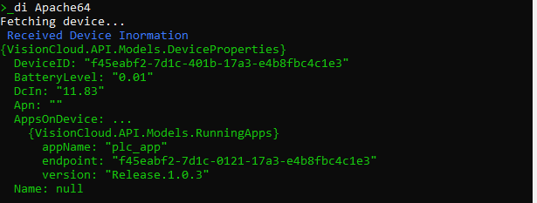

**sa | selectapp**  
Usage: sa ENDPOINT_ID  
Selects an application context for subsequent commands (especially operations). The ENDPOINT_ID should be one of the values listed under *AppsOnDevice endpoint* property in the results of running the *di* or *deviceinfo* command.



**cd | changedevice**  
Usage: cd DEVICE_NAME  
Changes to a different device. The DEVICE_NAME should be for a device that is registered and online.

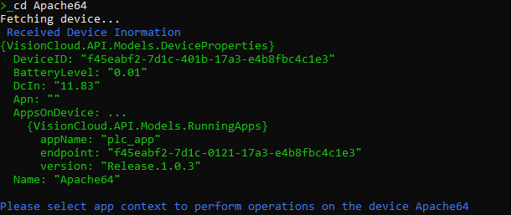

**rp | replay**  
Usage: rp  
Retrieves messages from the application (selected earlier with the *selectapp* command) for the given date range and downloads to the given directory. Provide the date range and local directory in the ensuing prompts. Date format is M/D/YYYY (leading zeros optional).

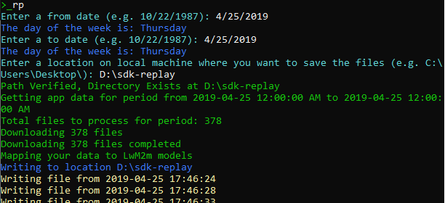

**op | operation**  
Usage: op  
Performs an operation on the application (selected earlier with the *selectapp* command). Provide the desired operation in the ensuing prompt. Operation can be given as the number or the text (eg *1* or *read*). Provide additional information as prompted.

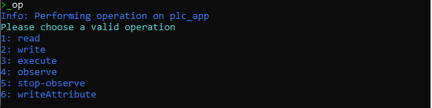

*Example:*To read the Manufacturer data,   
Enter the *op* command: op  
Enter the *read* subcommand: 1  
Enter the LWM2M message code for the Manufacturer object: 3/0/0 (note no leading /)

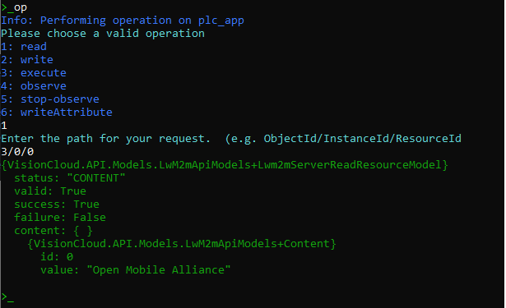

**exit**Closes the SDK app.